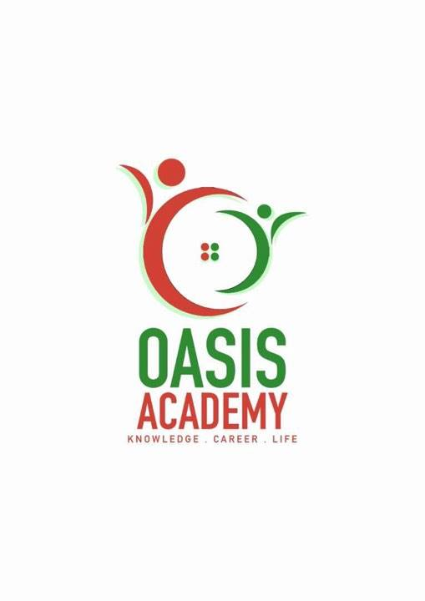

Name: Parthiban A/L Ramasamy

Login ID: parthiban@oasis-portal.com

Course title: Essentials of Human Resources

Subject Code: BHM01

Submitted date: 6/6/2017

**Table of Contents**

|  |  |  |
| --- | --- | --- |
| No | Details | Page |
| 1 | Executive Summary | 2 |
| 2 | Introduction | 3 |
| 3 | Assignment Question |  |
|  | Part 1 | 3-4 |
|  | Part 2 | 5-7 |
|  | Part3 | 8-9 |
|  | Part 4 | 10-13 |
| 4 | Conclusion | 14 |
| 5 | References | 15-16 |
| 6 | Appendix | 17-18 |

**Executive Summary**

In this module, I have learned about Essential of Human Resources Management. Human Resources Management is not a simple topic or small topic to explain and to understand. This Human Resources Management topic can be explain in many ways, and it’s also divided to many parts. Most probably in this module I’m going to explain more detail Human Resources in Hospitality Management. I will be able to understand the Human Resources Management and will explain the aspects of the questions in this part. First of all, I’m going start the module by explain about the major activities and Human Resources Operation which is very important to this tittle. And then, i will slightly brief about Human Resources Planning and the Trends. In addition, I will cover the topic with the Function and Policies of Human Resources. Last but not least, I will explain about Organizational Behavior in Hospitality and slightly will brief on Groups and Structure in Organization.

**Introduction**

At my point of view, I gain knowledge about Human Resources management in hospitality industry. Why we need to study Human Resource Management? Human Resources shows a positive roles in managing those subordinates and the workplace culture and the environment. The function of Human Resources is arm force, managing and directing people who work in. Human Resources are the most valuable and unique assets of an organization. These are few reason Human Resources Is important to organization such as strategy, compensation, benefits, safety, liability, training and development, employee stratification, recruitment, selection and compliance. Human Resources management also called personnel management has of all the activities undertaken by an enterprise. Furthermore to ensure the effective utilization of individual, group and organization goals. In addition many popular media production have depicted Human Resources. One of the television series The Office Human Resources representative Toby Flenderson seen as a nag cause he will constantly remind to his partner of company ethics and government regulation.

**Assignment Questions**

**Examples:**

Assignment question in this part contain 4 questions

**Question 1**

Define the Major Activities and Human Resources Operation in Hospitality Management.

**Answers**  (20 Marks)

The Major Activities in Hospitality Management are such as recruiting, selecting, training, motivation, evaluation, and compensation. These activities are very important to upgrade level of a company.

First of all, recruitment is a process of finding, searching or hiring suitable candidates (from within internal or external of an organization) to fill the positions. In a simple way recruiting is can understood as a process of searching for prospective employees and stimulating and encouraging people to apply for job in a company. Recruiting can spread in various ways. For example, by whitepaper, blog post, E-books, info graphics, surveys, videos, landing page and websites, and job descriptions.

Secondly, selecting is also a process of differentiating or comparing between candidates in order to identify those with the greater education level, skills, and working experience. Basically, selection will end after some process, it is means there are some process will be processing before the selection, such as preliminary interview, receiving applications, screening of application, employment tests, employment interview, checking references, physical examination, and then only the selection will be proceeding.

Hence, training will give to those who are attend and selected after the selection process. Most probably training will give by Human Resources Management (HRM) or trainers and supervisor. Training means is a workshop where employee can learn the skills and develop their knowledge which is taught or coached by Human Resources Management (HRM) or trainers and supervisor.  
  
 Thus, motivation means providing and incentive that would develop the productivity of an employee or individual. Human Resources Management (HRM) must play their role in this part to encourage the employee and also to achieve the organization or company goals.  
  
 Therefore, evaluation is a systematic process of determining the worth of a job according to other jobs in an organization. Evaluation starts with job analysis and ends at that point where the worth of the job is ascertained for achieving pay equity between jobs. In evaluation, there are some processes involved such as gaining acceptance, creating job evaluation committee, finding the jobs to be evaluated, analyzing and preparing job description, selecting the method of evaluation, classifying jobs.   
  
 What is the connection between Human Resources and hospitality management? Human Resources is very important to develop and improve the hospitality management operation such as front office, housekeeping, food and beverages, security and maintenance. Human elements are very important in service industry especially in hotel, restaurant, café and etc. The examples of work force in Human Resources (hospitality management) are such as waiter, waitress, receptionist, security and etc. This type of workers are directly will give service to the customers. In customer service career attitude and characteristic of the workers are more important compare to the skills. This is because customer satisfaction is most important in hospitality management.   
Whenever customer service is good enough, the organization will develop and grow automatically without any doubt. Examples of good customer service are following below.   
  
-Good standard of food and beverage  
-Provided   
-Good enough facilities   
-Accommodation  
-Respectful customer service  
  
Figure 1 shows the customer service of hotel industry   
  
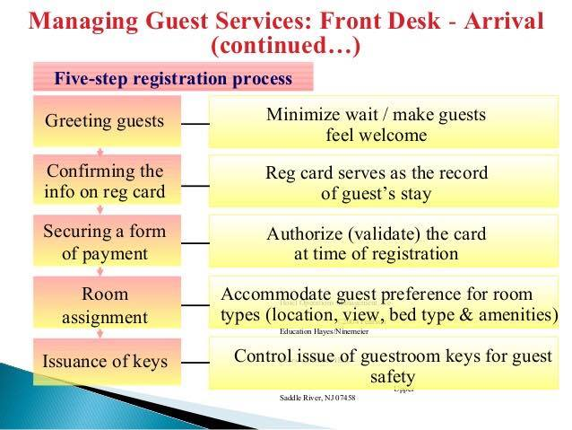  
  
  
  
  
  
  
  
  
  
  
  
  
  
  
Whenever Human Resources work in hospitality management, the development will always improve day by day. Customer satisfaction is very important in hospitality management.   
  
 Furthermore, compensation may be defined by as money received in performance of work plus many kinds of services and benefits that organization as provide to their employees. Compensation may be classified into a base or primary compensation and categorized into two such as Supplementary compensation. Primary it is a fixed and non-incentive payment on the basis of time expended on the job. Supplementary compensation consists of incentive and variable payments, based on either individual output or output of the group as a whole.

**Question 2**

Describe in brief on Human Resources Planning and Planning Trend in Hospitality.

Explain about what is your understanding on Action Plan Human Resources Planning in Hotel Industry.

(30 marks)

**Answer**  
Human Resources Planning means is a systematic steps or actions to recognize the current and future Human Resources needs for an organization to achieve its goals. There are a lot of objective of Humans Resources Planning such as provide control measure to ensure that necessary Human Resources is available as and when required, evaluate the surplus and shortage of Human Resources (right sizing), to present or yield direction to all over the Human Resources activities and systems and also make sure the prospective of line managers and staff are working together each and others (unite). Human Resource Planning is very important to future personnel needs, part of strategic planning, to creating highly talented personnel, international strategies, foundation for personnel function, increasing investments in Human Resources, resistance to change and move, and also to unite the perspective of line and staff managers. There also have some major steps in Human Resources Planning such as assessing Human Resources, demand forecasting, supply forecasting, matching demand and supply, and action plan.

Assessing Human Resources means is a custom of gathering data under systematic requirements and achieving a bottom line regarding the knowledge, qualification and potential of an employee. Human Resources demand forecasting is the operation of supposing the future quantities and quality of people requirements. Human Resources supply forecasting is the operation of assessing the changes of Human Resources followed after demand for testing of Human Resources. Forecasting supply of Human Resources divided for two parts as internal and external supply. Match demand forecasting and supply forecasting is like coordinating the both to make action in the end.

MATCHING DEMAND FORECASTING AND SUPPLY FORECASTING

SUPPLY FORECASTING

ASSESSING HUMAN RESOURCES

DEMAND FORECASTING

These four things are very important in Human Resources planning. Human Resources are to make predictions for the future necessarily of the organization, organization goals, and future developments. Human Resources planning are also main part of the organization’s strategic planning.  
  
  
Action plan is a dominant action such as requirement, selection, placement, training and development to the complete the Human Resources plan. All these actions are very important in Human Resources plan.   
  
There are five **“R”** helps to create a systematic Human Resources planning such as following below.   
  
**R**=Right number  
-right number of requirements /quantity of workers  
  
**R**= Right kind of people   
-Characteristic/ attitude, discipline/ for the right position  
  
**R**=Right time  
-Time management /punctual /season of requirement.  
  
**R**=Right place   
-Environment /field  
  
**R**=Right job  
-Right position/education and quality /experience   
  
these five **“R”** helps to create a systematic Human Resources planning in hospitality (hotel industry)

**Planning trends in hospitality**   
Trend as well as mean fashion. There are five type of Human Resources planning trend in hospitality such as outsourcing, internship, poaching and raiding, talent pool and E-recruitment.

**Outsourcing**

Out means external and sourcing means resources so, the both word giving meaning as workers from other countries. There are lot of benefits of outsourcing such as time saving, best performer, cost saving and excellent support.  
- Making talent pools   
-Submitting candidate’s information and details according to the necessarily of the company.  
-Company will make a final selection  
-Must pay the service charge Human Resources in hotel industry

**Internship**

Internshipmeans a person who work while study under a company or an organization with salary or without salary.   
-Work while study  
-Trainee post for after graduation Human Resources management in hotel industry

**Poaching and raiding**-“Buying talent” rather than improve it.  
-Promoting impressive packages and other terms and conditions, better than the current employer of the candidate.  
-Unethical practice  
-It has become a challenge for Human Resources managers to face and tackle poaching as it weakness the competitive strength of the firm. Human Resources planning in hotel industry.

**E-recruitment**

Basically E brings meaning as online and then recruitment bringing as finding new people to work in their company. So, totally bring a meaning as finding candidate’s through online with the help of network. Benefits of E-recruitment are can save time and also save cost.  
-Promoting job vacancy through network and internet.   
- Cheap cost Human Resources planning in hotel industry.  
-Receiving candidate’s information from email  
-Interviewing through support of information technology (IT)  
-Requirements of good type of people

**Talent pool**

Talent pool can be defined as a person who are skilled can be a worker in a particular jobs.  
-Building database by using network.  
-Many requirement agency   
-Privacy Human Resources planning in hotel industry

**Question 3**

Brief about Human Resources Functions and Human Resources Policies.

Describe the Functions of Management and how the policy applies accordingly in Hospitality Management. (30 marks)

**Human Resources Function**Human resources functions can be divided into two parts as managerial function and operative function. Firstly, let’s we understand about what is managerial function, is bring the same meaning as administrative and executive employment or responsibility of an organization. In this case, there are four function in managerial part, such as planning, organizing, directing and controlling.

**Planning**-Planning means is a process to make something with a cooperation of all members. Planning also mean as discussion about to improve something to achieve their future goals.

**Organizing   
-**Organizing means arranging or coordinating something to succeed.

**Directing   
-**Directing can be defined as managing or guiding by advising, giving useful informations and instructions and etc. At the same time it also means administrating or supervising something become better.

**Controlling   
-**Controlling means most probably is same as supervising and dominating something as well as can to be succeed.

These four things are very important the reason why there have connection between each and others managerial function and also operative function. Let’s we understand about what is operative functions? Operative function divides to five types of functions as procurement, development, compensation, integration, maintenance.

**Procurement**-procurement will start with job analysis and then requirement, selection, placement and induction and also transfer. Promotion and separation is also under procurement.

**Development**

Development means the improvements that happen in hotel industry. Mainly, the development will improve in performance appraisal, training, executive development and also career planning.

**Compensation**

Compensation and benefits is the best function in operative function. There are two types such as compensation structure and evaluating competitive pay training. At the same time, employees will get festival bonus, joining bonus, New Year bonus, and retire bonus and also have health care benefits.

**Integration**

Integration is the thing must have in a company to develop a company (hotel industry). Integration such as motivation, job satisfaction, participations of employee and also discipline. These things are very important in hotel industry.

**Maintenance**

Maintenance mainly focus in safety of the employees. Safety is a very important factor in a working place such as security. Then, personal records and health record are under the maintenance.

Human Resources policies are very important in an organization. The company will promoting guideline on the approach a business. In Human Resources management policies are divided into four certain of policies. For example, organizational structure, legal issue, supervising guide, and consistency. Human Resources function can be used in the hospitality operation. In this case the candidates who worked under hospitality management (hotel industry) can earn more money and extra money by getting their tips from the customers. The most serious problem are employment related. Too many peoples are interesting to involve or to make a career in hotel industry. To attracting and retaining skill worked a lack of worker’s satisfaction and training also be less in hotel industry.

**Question 4**

Explain in detail about Organizational Behavior in Hospitality and brief on Groups and Structure Organization.

**Answer**  
Organizational Behavior means the learning of human behavior, human attitudes and human behaviors in a company or organization. Firstly, we have to understand about the meaning of organizational it means, more than two person or two individuals and at the same time behavior means observable activity in a human. So, organizational behavior brings the meaning as the cooperation of two individuals or a group to achieve their goals their company organization. In detail, organizational behavior can be form as the learning of what people think, what people feel, what people do in and around organization. Is all about, people’s action, reactions and interactions in a company organization.  
  
There are lot of dominance of organizational behavior such as following below.

-Understanding

-other people behavior

- Retain good working environment

-Focus in the goals that have to achieve

-Relationship between employer and employees

-To build an effective company

Let’s we focus organizational behavior in hotel management (hotel industry). Human Resources in hospitality (peoples who work in hotel Industry) handle lot of issues on this title (organizational behavior) . The followings are type of problem that are handle by Human Resources in organizational behavior.

-Work force

-Skills and talent

-Labor shortage

-Declining

-Loyalty

This type of problems always will grows and not will end if the organizational behavior is not good enough in an organizational or in a company. From this, we can understand about that behavior is very important that have to focus by Human Resources in hospitality. This is why Human Resources in hospitality (hotel Industry) are very difference. For example, peoples who work in hotel Industry are type of personalities, attitude, and characteristic. Even though they are different kind of people, we must be in a group (team work) to improve and develop organizational behavior in hotel industry.

As we all know, hospitality management is very competitive in economy nowadays and there are some bad attitude of people are not suitable for this business because of them the business will effected (bankrupt) . Altitudes are focus is almost very important in customer service line, especially, in hotel. In another hand, teamwork is a dominant thing that have to improve in hotel industry.

Group

Organization

Individual

**Organizational** **behavior** **in** **group**

Organizational behavior in group means to of four person cooperate each and others to success and to achieve their future goals. There are two types of groups in an organization such as formal groups and Informal group. In formal group we have another two types of groups such as command group and task group. By the way, in informal group we have another two types of groups such as friendship group and interest group. The advantage of being in a group is such as following below.

-Can develop status level

-Can show the power of the team in completing task

-Self-esteem will improve

-Always have guide (safety and security)

-Can put effort to achieve the goal achievement.

Group is also very important in taking a decision. In good things in a group is such as following below.

-Can get a more information and knowledge

-Perspective higher in a team

-Can correct each another mistakes

-A lot of creativity

-Can combine and share the skills each and others.

Even though there are lot of pros of win the group, organizational group also have some cons such as taking too much of the time to complete the task and can be subject to minority domination . To avoid this kind of cons, understanding each and another is the right solution. There are some stages in a working team such as forming, storming, and norming, performing and adjourning.

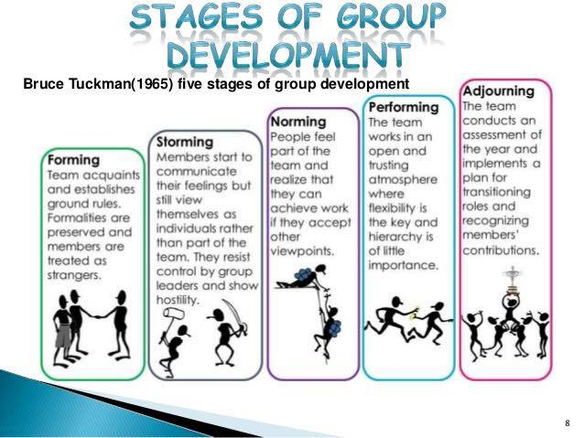Figure 2 shows the stages of group development.

**Organization** **structure**

Organization structure means is a systematic way to organize and organization on what is the positions for a person, what is the responsibility of a person, level of a person and how various work roles. Organization structure give an impact effectively. Organization structure also help to reduce redundant actions. Organizational structure also make a team work in an organization. Furthermore, commutation also will improve when the organization structure works. In every department and industries there got their own organizational structure. Whenever the organization structure works in a company or in an organization, definitely that company can avoid the conflict that’s happen nowadays. The following below are elements of organization structure.

-Work specialization

-Departmentalization

-Chain of command

-Span control

-Centralization

-Formalization

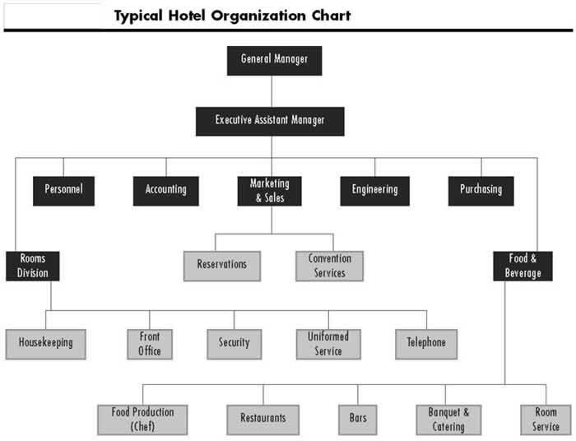These elements are help to organization structure work on. Organization structure in hotel industry will start from the general manager following with the assistant manager until the cleaners. The following figure will shows an example of organization structure (chart) of a typical hotel.  
  
Figure 3 shows typical hotel organization chart

**CONCLUSION**From the above fact it can be concluded that the emergence of the strategic role of Human Resources Managers as a paradigm shift generated more value- added core responsibility. Marketing planning improves the chances of survival and success. Future is uncertain, environment trends can be identified and evaluated. Marketing planning provides hospitality companies with a structured approach to planning for the future. Human Resources the main aim of HR manager is to provide the best candidate in the From the above fact it can be concluded that the emergence of the strategic role of Human Resources Managers as a paradigm shift generated more value- added core responsibility. Marketing planning improves the chances of survival and success. Future is uncertain, environment trends can be identified and evaluated. Marketing planning provides hospitality companies with a structured approach to planning for the future. Human Resources the main aim of HR manager is to provide the best candidate in the hotel. The main work of HR is the right person at right place. Marketing the main aim of marketing management is to satisfy the customer and sale the product with good image. Production is the main of production management is to provide the best quality, quantity food to the customer and to reduce wastage. Finance is the main of finance management is to reduce the cost of production, marketing and to maximize profit.

**REFERENCES**1. Zeinul Haleem (Sep 21, 2014) Human Resource Management in Hotel Industry  
• [https://www.slideshare.net/ZeinulHaleem2/human-resource-management-in-hotel-industry](https://l.facebook.com/l.php?u=https%3A%2F%2Fwww.slideshare.net%2FZeinulHaleem2%2Fhuman-resource-management-in-hotel-industry&h=ATPNT-PXfL7Y1NHbN5XSZv_fwF-3u9hYYvUILeEXb2EfKkGZ2Qu_jW00cCGGM_kV__qjX1hiFj6g_VReuUefJzaoX1LqmtR8uSlYyIPzFVMvWbXoJZEb8mHKBPADh7gtL16gSa5h7Och)  
2. Crystial Abram P. Parrilla (Jul 13, 2015) Introduction to Human Resource Management in Hospitality Industry  
• [https://www.slideshare.net/CrystialParrilla/introduction-to-human-resource-management-in-hospitality-industry](https://l.facebook.com/l.php?u=https%3A%2F%2Fwww.slideshare.net%2FCrystialParrilla%2Fintroduction-to-human-resource-management-in-hospitality-industry&h=ATPNT-PXfL7Y1NHbN5XSZv_fwF-3u9hYYvUILeEXb2EfKkGZ2Qu_jW00cCGGM_kV__qjX1hiFj6g_VReuUefJzaoX1LqmtR8uSlYyIPzFVMvWbXoJZEb8mHKBPADh7gtL16gSa5h7Och)  
  
3. Somitra Upadhyay (Nov 27, 2014) HR Policies of Hotels  
• [https://www.slideshare.net/SomitraUpadhyay/hr-policies-of-fortune-landmark-hotel-and](https://l.facebook.com/l.php?u=https%3A%2F%2Fwww.slideshare.net%2FSomitraUpadhyay%2Fhr-policies-of-fortune-landmark-hotel-and&h=ATPNT-PXfL7Y1NHbN5XSZv_fwF-3u9hYYvUILeEXb2EfKkGZ2Qu_jW00cCGGM_kV__qjX1hiFj6g_VReuUefJzaoX1LqmtR8uSlYyIPzFVMvWbXoJZEb8mHKBPADh7gtL16gSa5h7Och)  
4. Ruth Mayhew (1985) Key Human Resource Management Policies & Procedures  
  
• [http://smallbusiness.chron.com/key-human-resource-management-policies-procedures-60802.html](https://l.facebook.com/l.php?u=http%3A%2F%2Fsmallbusiness.chron.com%2Fkey-human-resource-management-policies-procedures-60802.html&h=ATPNT-PXfL7Y1NHbN5XSZv_fwF-3u9hYYvUILeEXb2EfKkGZ2Qu_jW00cCGGM_kV__qjX1hiFj6g_VReuUefJzaoX1LqmtR8uSlYyIPzFVMvWbXoJZEb8mHKBPADh7gtL16gSa5h7Och)  
  
5. Dr. Rajasshrie Pillai (Aug 22, 2014) Chapter 1 Organizational Behavior  
• [https://www.slideshare.net/rajasshrie1/chapter-1-ob-38248150](https://l.facebook.com/l.php?u=https%3A%2F%2Fwww.slideshare.net%2Frajasshrie1%2Fchapter-1-ob-38248150&h=ATPNT-PXfL7Y1NHbN5XSZv_fwF-3u9hYYvUILeEXb2EfKkGZ2Qu_jW00cCGGM_kV__qjX1hiFj6g_VReuUefJzaoX1LqmtR8uSlYyIPzFVMvWbXoJZEb8mHKBPADh7gtL16gSa5h7Och)  
  
6. Dr. Daisy Chauhan (May 8, 2009) Basic Concepts of Organizational Behavior  
• [https://www.slideshare.net/manishray/1basicconceptsofob](https://l.facebook.com/l.php?u=https%3A%2F%2Fwww.slideshare.net%2Fmanishray%2F1basicconceptsofob&h=ATPNT-PXfL7Y1NHbN5XSZv_fwF-3u9hYYvUILeEXb2EfKkGZ2Qu_jW00cCGGM_kV__qjX1hiFj6g_VReuUefJzaoX1LqmtR8uSlYyIPzFVMvWbXoJZEb8mHKBPADh7gtL16gSa5h7Och)  
7. UK essays (23rd March, 2015) Importance of Human resource management in Hospitality Industry Tourism Essay  
• [https://www.ukessays.com/essays/tourism/importance-of-hrm-in-hospitality-industry-tourism-essay.php](https://l.facebook.com/l.php?u=https%3A%2F%2Fwww.ukessays.com%2Fessays%2Ftourism%2Fimportance-of-hrm-in-hospitality-industry-tourism-essay.php&h=ATPNT-PXfL7Y1NHbN5XSZv_fwF-3u9hYYvUILeEXb2EfKkGZ2Qu_jW00cCGGM_kV__qjX1hiFj6g_VReuUefJzaoX1LqmtR8uSlYyIPzFVMvWbXoJZEb8mHKBPADh7gtL16gSa5h7Och)  
8. Aditya Modani (Dec 3, 2007) Human Resource Planning In Hotel Business  
• [https://www.slideshare.net/guest61a8d3/human-resource-planning-in-hotel-business?qid=f3337641-290d-4276-85f7-ba2a50f1eee5&v=&b=&from_search=](https://l.facebook.com/l.php?u=https%3A%2F%2Fwww.slideshare.net%2Fguest61a8d3%2Fhuman-resource-planning-in-hotel-business%3Fqid%3Df3337641-290d-4276-85f7-ba2a50f1eee5%26v%3D%26b%3D%26from_search%3D&h=ATPNT-PXfL7Y1NHbN5XSZv_fwF-3u9hYYvUILeEXb2EfKkGZ2Qu_jW00cCGGM_kV__qjX1hiFj6g_VReuUefJzaoX1LqmtR8uSlYyIPzFVMvWbXoJZEb8mHKBPADh7gtL16gSa5h7Och)  
  
9. Giovanni Macahig (Jun 29, 2013) Fundamentals of organizational behavior ppt  
• [https://www.slideshare.net/rahu1515/fundamentals-of-organizational-behavior-ppt](https://l.facebook.com/l.php?u=https%3A%2F%2Fwww.slideshare.net%2Frahu1515%2Ffundamentals-of-organizational-behavior-ppt&h=ATPNT-PXfL7Y1NHbN5XSZv_fwF-3u9hYYvUILeEXb2EfKkGZ2Qu_jW00cCGGM_kV__qjX1hiFj6g_VReuUefJzaoX1LqmtR8uSlYyIPzFVMvWbXoJZEb8mHKBPADh7gtL16gSa5h7Och)  
10. Payal Deep (Dec 17, 2012) Organizational behavior  
• [https://www.slideshare.net/payalrchhabra/organisational-behavior-15668552](https://l.facebook.com/l.php?u=https%3A%2F%2Fwww.slideshare.net%2Fpayalrchhabra%2Forganisational-behavior-15668552&h=ATPNT-PXfL7Y1NHbN5XSZv_fwF-3u9hYYvUILeEXb2EfKkGZ2Qu_jW00cCGGM_kV__qjX1hiFj6g_VReuUefJzaoX1LqmtR8uSlYyIPzFVMvWbXoJZEb8mHKBPADh7gtL16gSa5h7Och)  
11. Ruth Mayhew (1985) 10 Reasons HR Is Important to an Organization  
  
• [http://smallbusiness.chron.com/10-reasons-hr-important-organization-22424.html](https://l.facebook.com/l.php?u=http%3A%2F%2Fsmallbusiness.chron.com%2F10-reasons-hr-important-organization-22424.html&h=ATPNT-PXfL7Y1NHbN5XSZv_fwF-3u9hYYvUILeEXb2EfKkGZ2Qu_jW00cCGGM_kV__qjX1hiFj6g_VReuUefJzaoX1LqmtR8uSlYyIPzFVMvWbXoJZEb8mHKBPADh7gtL16gSa5h7Och)   
12. Wikipedia  
• [https://en.m.wikipedia.org/wiki/Human_resource_management](https://l.facebook.com/l.php?u=https%3A%2F%2Fen.m.wikipedia.org%2Fwiki%2FHuman_resource_management&h=ATPNT-PXfL7Y1NHbN5XSZv_fwF-3u9hYYvUILeEXb2EfKkGZ2Qu_jW00cCGGM_kV__qjX1hiFj6g_VReuUefJzaoX1LqmtR8uSlYyIPzFVMvWbXoJZEb8mHKBPADh7gtL16gSa5h7Och)  
13. George Elton mayo  
• [http://www.whatishumanresource.com/the-historical-background-of-human-resource-management](https://l.facebook.com/l.php?u=http%3A%2F%2Fwww.whatishumanresource.com%2Fthe-historical-background-of-human-resource-management&h=ATPNT-PXfL7Y1NHbN5XSZv_fwF-3u9hYYvUILeEXb2EfKkGZ2Qu_jW00cCGGM_kV__qjX1hiFj6g_VReuUefJzaoX1LqmtR8uSlYyIPzFVMvWbXoJZEb8mHKBPADh7gtL16gSa5h7Och)  
14. 17 June, 2011 the Importance of Human Resource Management  
  
• [https://www.griffith.ie/blog/importance-human-resource-management](https://l.facebook.com/l.php?u=https%3A%2F%2Fwww.griffith.ie%2Fblog%2Fimportance-human-resource-management&h=ATPNT-PXfL7Y1NHbN5XSZv_fwF-3u9hYYvUILeEXb2EfKkGZ2Qu_jW00cCGGM_kV__qjX1hiFj6g_VReuUefJzaoX1LqmtR8uSlYyIPzFVMvWbXoJZEb8mHKBPADh7gtL16gSa5h7Och)  
15. Ruth Mayhew (1985) What Are the Functions of Human Resource

**APPENDIX**Figure 1 shows the customer service of hotel industry

  
  
  
  
  
  
  
  
  
  
  
  
  
Figure 2 shows the stages of group development

Figure 3 shows typical hotel organization chart



**THE END**